


EURO-CIU

Programme

Cochlear implantation:
long-term issues – access and management

20 April 2007

Chairman: Professor Gerry O’Donoghue

10:00 – 10:15 Welcome

10:15 – 10:45 Cochlear implantation:
access and reliability Gerry O’Donoghue (UK)

10:45 – 11:30 Round Europe – access and issues
- Sweden Ann-Charlotte Gyllenram
- France Gilles Cognat
- The Netherlands Ruud van Hardeveld
- Central & Eastern Europe Monika Lehnhardt

11:30 – 12:15 Children:
Long-term management and outcomes Sue Archbold (UK)

12:15 – 13:30 EXHIBITION AND LUNCH

Chairman: Professor Quentin Summerfield

13:30 – 14:00 Rehabilitation of cochlear implant users Volker Kratzsch
- what will change and what will remain (Germany)
in psycho- and social situation of users

14:00 – 14:30 Young people: Liz Beadle (UK)
what are their issues? Rebecca French (UK)
& Sheena Parmar (UK)

14:30 – 15:00 Adults with cochlear implants:
long-term support Geoff Plant (USA)
(Sponsored by MED-EL)
15:00 – 15:30 Cochlear implantation:
family and psycho-social issues Lorraine Gailey (UK)

15:30 – 16:00 Current Research & Summary:
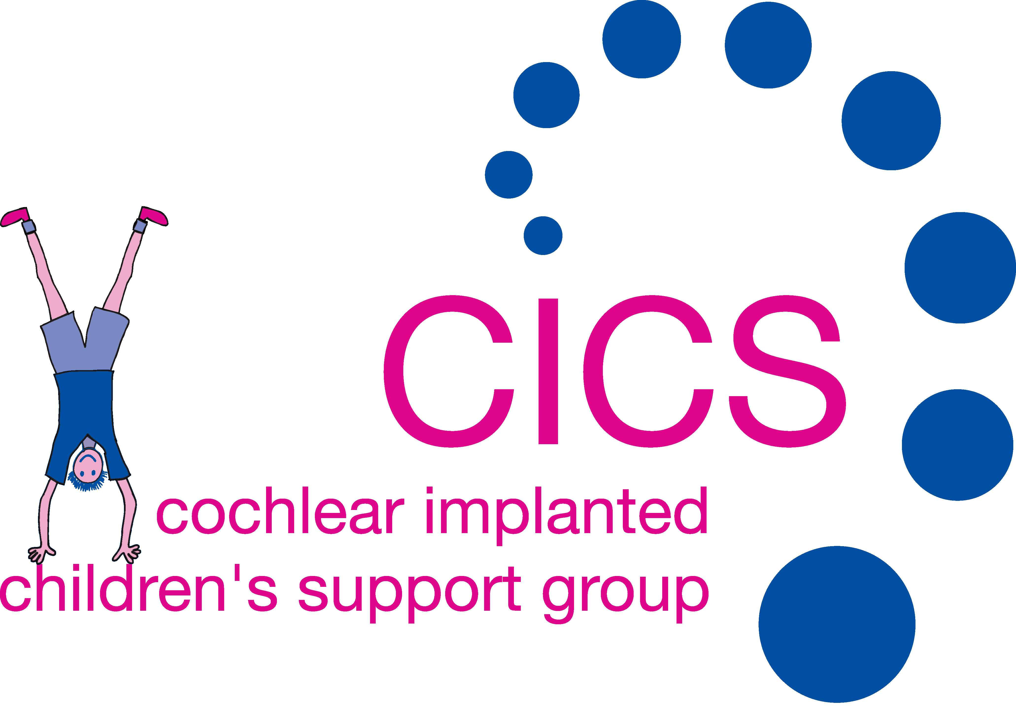

(Title of talk to be agreed) Quentin Summerfield (UK)

